Mechanical Ventilation

DEFINITION:
Mechanical ventilation is a life support treatment. Mechanical Ventilation is ventilation of the lungs by artificial means usually by a ventilator . Amechanical ventilator is a machine that helps people to breathe when they aren't able to breathe enough on their own. A ventilator delivers gas to the lungs with either negative or positive pressure
INDICATIONS:
Most patients who need support from amechanical ventilator because of severe illness are cared for in hospital intensive care unit(ICU).They need mechanical ventilator to:
(1) Get oxygen to lungs and body.
(2)Help the lungs to git rid of carbon dioxide.
(3)Ease the work of breathing.
(4)Breathe for patient who isn't breathing because of brain damage or injury or high spinal cord injury or very weak muscles
1- Acute respiratory failure due to:
Mechanical failure.
Musculoskeletal abnormalities.
Infectious diseases of the lung such as pneumonia, tuberculosis.
2- Abnormalities of pulmonary gas exchange as in:
Obstructive lung disease
pulmonary edema, pulmonary fibrosis.
Patients who has received general anesthesia as well as post cardiac arrest patients.

Normal range | Ventilation indicated | Parameters
10-20  5-7  7.35-7.45  75-100  35-45 | > 35  < 5  < 7.25  <60  >50 | A- Pulmonary function studies:  Respiratory rate  (breaths/min).  Tidal volume (ml/kg  body wt)  B- Arterial blood Gases :  PH  PaO₂ (mmHg)  PaCO₂ (mmHg)
Types of Mechanical ventilators:
- Positive-pressure ventilators.
- Negative-pressure ventilators
- Negative-Pressure Ventilators
- Early negative-pressure ventilators were known as “iron lungs.”
- The patient’s body was encased in an iron cylinder and negative pressure was generated .
The iron lung are still occasionally used today

Positive-pressure ventilators
Positive-pressure ventilators deliver gas to the patient under positive-pressure, during the inspiratory phase.
Positive pressure ventilation may be:
(1)Invasive PPV.
(2)Non invasive PPV.
Invasive PPT:
The ventilator is connected to the patient through an endotracheal tube or atracheostomy tube and blows gas into the patients lung.
Airway intubation Methods

:
- Endotracheal intubation.
Orotracheal
Nasotracheal
- Tracheotomy.

Endotracheal Intubation
- Definition:
Placement of a flexible plastic tube into the trachea to maintain an open airway.

- Instruments used:
1-Self-refilling bag-valve combination (eg, Ambu bag)
2- Tincture of benzoin and precut tape.
3. Introducer (stylets or Magill forceps).
4. Suction apparatus (tonsil tip and catheter
suction).
5. Syringe, 10-mL, to inflate the cuff.
6. Mucosal anesthetics (eg, 2% lidocaine)
7. Water-soluble sterile lubricant.
8. Gloves.
9.Laryngoscope.
10-Endotracheal tube.

Stethoscope
Commercial securing device
Secondary confirmation device
Technique: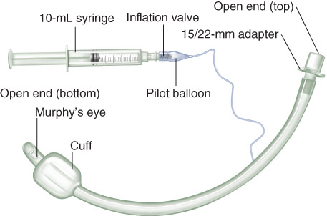
- Sniffing position:
Flexion at lower cervical spine .
Extension at the atlanto-occipital joint.
1)Topical Anesthesia: Anesthetize the mucosa of the oropharynx, and upper airway with lidocaine 2%, if time permits and the patient is awake.
(2)Direct Laryngoscopy:
Place the patient in the sniffing position. Check the laryngoscope and blade for proper fit, and make sure that the light works.
Grasp the laryngoscope in the left hand.
Spread the patient's lips, and insert the blade between the teeth, being careful not to break a tooth.
Pass the blade to the right of the tongue, and advance the blade into the hypopharynx, pushing the tongue to the left.
Lift the laryngoscope upward and forward, without changing the angle of the blade, to expose the vocal cords.
The tube is inserted through the cords to the point that the cuff rests just below the cords.
Finally, the cuff is inflated to provide a minimal leak .
Confirm tube position
By auscultation of the chest.
Bilateral chest rise.
Tube location at teeth.
CO2 detector.
Two types of CO₂ Detector
Colorimetric: Change Color
Capnographs
The depth of the tube for a male patient on average is 21-23 cm at teeth The depth of the tube fora female patient on average is 19-21 cm at teeth
Nasoendotracheal intubation
Advantages:
1) Comfortable for prolong intubation in postoperative period
2) Suitable for oral surgery : tonsillectomy , mandible surgery
3) For blind nasal intubation
4) Can take oral feeding
5) Resist for kinking and difficult to accidental extubation
Disadvantages:
1) Trauma to nasal mucosa
2) Risk for sinusitis in prolong intubation
3) Risk for bacteremia
4) Smaller diameter than oral route difficult for suction.
Contraindications for nasoendotracheal intubation:
1) Fracture base of skull
2) Coagulopathy
3) Nasal cavity obstruction
4) Retropharyngeal abscess
Tracheostomy
Making an incision on the front of the neck and opening a direct airway through an incision in the trachea.
Allows a person to breathe without the use of their nose or mouth
Used primarily in situations where a prolonged need for airway support is anticipated.
COMPONENTS OF TRACHEOSTOMY
SIZES RANGE FROM 2.5MM TO 11 MM
CURVED TUBE
INFLATABLE CUFF
FLANGES WITH HOLES
TUBE BLADDER
Secured in place by tapes tied around the neck
Non Invasive Mechanical Ventilation
ADVANTAGES OF NIMV
Preservation of airway defense mechanism
Early ventilatory support an option

Intermittent ventilation possible
Patient can eat, drink and communicate
Ease of application and removal
Patient can cooperate with physiotherapy
Improved patient comfort
Reduced need for sedation
Avoidance of complications of endotracheal intubation: upper airway trauma, sinusitis, otitis, nosocomial pneumonia
Ventilation outside hospital possible
Correction of hypoxemia without worsening hypercarbia
Devices of ENPV:
Tank ventilator “iron lung”: the most effective one.
Cuirass.
Jacket ventilator.
NIPPV can be applied most commonly with either:
- Nasal mask.
- Full face mask
-Laryngeal Masks (LMA).
Contraindications for NIV:
Respiratory arrest/Cardiac arrest.
Medically unstable (hemodynamically unstable, arrythmias, cardiogenic shock).
Unable to protect airway.
Excessive secretions.
Uncooperative or agitated.
Unable to fit mask (facial trauma/surgery).
Recent upper airway or GI surgery.

Ventilator Associated Pneumonia (VAP)
DEFINITION
VAP is defined as a PNEU that occurs in patients receiving invasive mechanical ventilation for at least 48 hours.
VAP onset
Early onset VAP: 2-3 days after mechanical ventilation.
Late onset VAP: >4 days after mechanical ventilation.
Incidence
VAP is the 2nd most common nosocomial infection = 15% of all hospital acquired infections
Incidence = 9% to 70% of patients on ventilators
Increased ICU stay by several days
Increased avg. hospital stay 1 to 3 weeks
55%-Mortality = 13%
Risk factors for Nosocomial Pneumonia :
Major risk factor :
(1)Factors that enhance colonization of the oropharynx &/or stomach:
Administration of antibiotics
Admission to ICU
Underlying chronic lung disease
(2)Conditions favoring aspiration into the respiratory tract or reflux from GI tract:
* Supine position
*GERD
* NGT placement *Coma/delirium.
Intubation and self-ex tubation * Immobilization
Surgery of head/neck/thorax/upper abdomen
(3)Conditions requiring prolonged use of mechanical ventilatory support :
with potential exposure to contaminated respiratory devices &/or contact with contaminated hands
(4)Host Factors:
Extremes of age
Malnutrition
Immunocompromised
Underlying condition/disease process
The Intensive Care Unit
Sickest patients in the hospital
More likely to have infections.
Worse outcomes of infections.
More invasive devices.
More multidrug resistant organisms (MDROs).
VAP Pathogenesis
(1)Intubation impairs natural defenses.
Cough and gag reflex
Mucociliary clearance
(2)Tube is a direct conduit into lower respiratory tract
No longer sterile
Tracheobronchial tree becomes colonized within hours.
(3)Ventilator circuit can become colonized within 24 hours.
Probable routes of transmission of pathogens leading to VAP
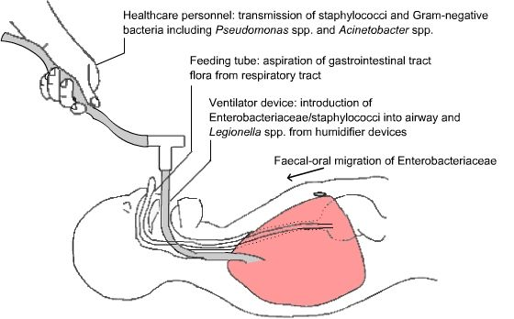

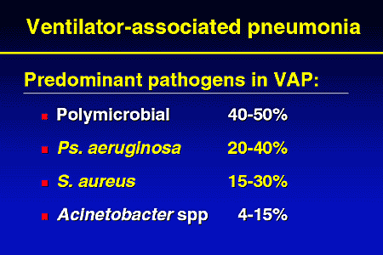

Pathogens in VAP
(A)-Early–Onset Pneumonia (< 96 hours of intubation or ICU admission)
Community-acquired
Pathogens:
Streptococcus pneumoniae
Haemophilus influenzae
Staphylococcus aureus
Antibiotic-sensitive
(B)-Late-Onset Pneumonia (> 96 hours of intubation or ICU admission)
Hospital-acquired
Pathogens:
Pseudomonas aeruginosa
Methicillin resistant Staphylococcus aureus (MRSA)
Acinetobacter
Enterobacter
Antibiotic-resistant
VAP DIAGNOSIS
There is no gold standard for diagnoses of VAP hence; combined clinical, radiological, and microbiological data are needed for correct diagnoses. An integrated approach should be followed in diagnoses of VAP:
(CPIS): Clinical Pulmonary Infection Score
Temperature (0-2)
WBC Count (0-1)
PaO₂/FiO₂ (0-2)
Chest X-ray (0-2)
Quality of tracheal secretions (0-2)
Progression of infiltrate (0-2)
Culture of aspirate (0-2)

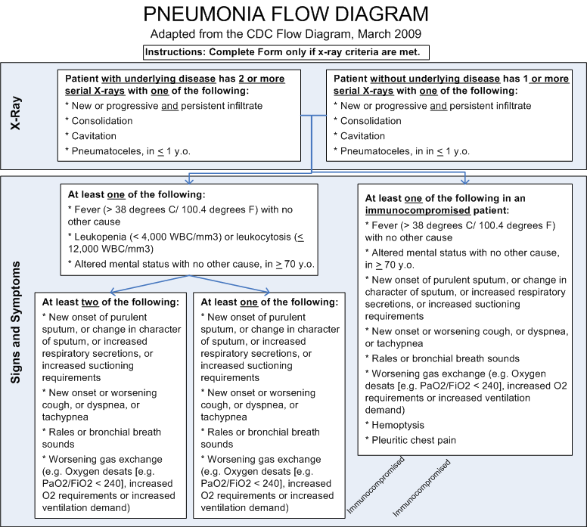
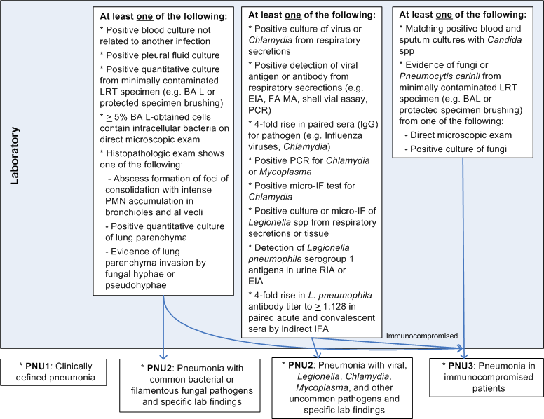

Microbiological diagnosis
The challenge for microbiological laboratory diagnosis is to discriminate between the pathogenic organism and the normal flora present in the respiratory samples, because clinical and radiolological features can`t discriminate caustive organism and microbiological results should guide the therapy.
The microbiological diagnosis of VAP is based on:
direct microscopic examination.
qualitative and quantitative culture of lower respiratory tract secretions obtained bronchoscopically or non-bronchoscopically .
Sampling methods::
Techniques for lower respiratory tract sampling in ventilated patients include:
(1) Non-bronchoscopic methods:
(1) Endotracheal aspirate.
(2)Bronchial lavage .
(3) Blind invasive techniques.
(2)Bronchoscopic methods: (1) Bronchoalveolar lavage BAL. (2) Protected specimen brush ( PSB)
Non-bronchoscopic techniques
A) Non-invasive techniques:
(1)Endotracheal aspirate (EA):
Quantitative endotracheal aspirate (EA) culture may be an acceptable tool for diagnosing VAP.
2)Non-directed bronchial lavage (NBL)
Non directed bronchial lavage (NBL) is better than Endotracheal aspirate
Procedure of NBL is simple:
20 ml of 0.9% saline was instilled through a catheter transiently placed in the bronchial tree through the endotracheal tube. The saline is then immediately aspirated back into a syringe yielding a return of between 5 and 10 mls.
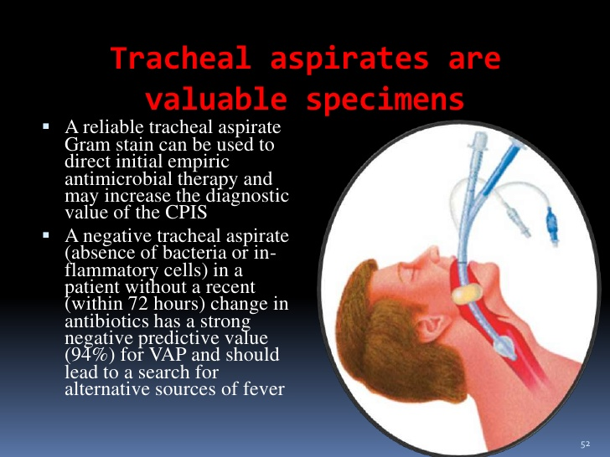
(B)Blinded Invasive Diagnostic Procedures:
(1)blinded bronchial sampling (BBS). (2) mini-BAL . (3) blinded sampling with the protected-specimen brush (BPSB) technique, using several different protected brushes.
1-Blinded bronchial sampling (BBS)
The catheter is blindly wedged into a distal bronchus and aspirated secretions are recovered. No fluid is instilled during any of the procedures. Most investigators required a minimal amount of recovered secretions, usually on the order of 1 to 2 mls. Quantitative cultures are performed, and the concentration of bacteria considered significant for the diagnosis of pneumonia ranged from 103to 104 cfu/mL.
:2)Mini-BAL)
The amount of lavage fluid instilled varied from 20 to 150 mL. Quantitative cultures are performed, and the bacterial concentration considered significant for the diagnosis of pneumonia ranged from 103 to 104 cfu/mL .
:(3)Protected-specimen brush (BPSB)
This method incorporates a sterile brush that is protected from contamination. There are several different protected brushes. A sterile, single-use, containing a nylon specimen brush 16 mm long at its tip.Quantitative cultures are performed, and a level of 103 cfu/mL was considered significant for the diagnosis of pneumonia
Bronchoscopic specimens:
Fiberoptic bronchoscope is used to provide direct access to the lower airways for sampling bronchial and parenchymal tissues directly at the site of lung inflammation. Bronchoscopy allow proper selection of the sampling area in the tracheobronchial tree based on the location of infiltrate on chest radiograph or the segment visualized during bronchoscopy as having purulent secretions.
:(1)Broncho alveolar lavage (BAL)
BAL requires careful wedging of the tip of the bronchoscope into an airway lumen, isolating that airway from the rest of the central airways. Infusion of at least 120 mL of saline is needed to sample fluids and secretions in the distal respiratory bronchioles and alveoli .
(2)Protected specimen brushing (PSB)
PSB are collected with a brush within two telescoping catheters, the outer of which is occluded with a Carbowax plug. The Carbowax plug prevents secretions from entering the catheters during passage through the bronchoscope channel. Once the device has been passed through the bronchoscope channel, the inner catheter is advanced. The Carbowax plug is expelled into the airway lumen, where it is absorbed.
Invasive sampling
:Advantages
May exclude pneumonia
May allow more specific diagnosis
May allow antibiotic treatment to be optimised
Other advantages of direct visualisation and manipulation of airway
Disadvantages
Invasive
Expensive
Time consuming
Potential airway trauma and/or infection risk
Techniques that help maximize fluid return include:
The patient lies on the affected side and the head is turned to the opposite side.
Instructing the patient to breathe deeply during fluid instillation and during suctioning.
Wedging the bronchoscope deep inside the segmental bronchus.
.An inadequate sample:
Less than 10% of instilled volume.
Greater than 2% columnar epithelial cells.
Gram’s staining:
The Gram's staining is useful to detect bacteria and yeast cells in the respiratory secretions. The percentages of squamous epithelial or bronchial cells may be used to predict heavy upper respiratory contamination.
The presence of more than 1% epithelial cells or 10 epithelial cells per low-power field (magnification, ×100) has been proposed as a rejection criterion. .
:Giemsa staining
Giemsa staining is recommended for evaluation of VAP, as it offers a number of advantages over Gram's staining, including better visualization of host cell morphology, improved detection of bacteria, particularly intracellular bacteria, and detection of some protozoan and fungal pathogens, such as Histoplasma capsulatum, Pneumocystis jirovecii, Toxoplasma gondii, and Candida spp.
The cut-off point of <2% of cells containing intracellular bacteria had the highest sensitivity (80%) and specificity (82%) in the microscopic examination of non bronchoscopic protected broncho alveolar mini-lavage (mini-PBAL) fluid for the diagnosis of VAP
negative direct staining :
- previous antibiotic therapy
- steroids
- presence of Pseudomonas aeruginosa .
Microbiological findings are useful mainly based on two rules:
1. the presence of intracellular bacteria
2. a positive Gram stain (or other direct tests)
may be of great help in selecting the initial antibiotic regimen but not in making the diagnosis of pneumonia
Culture:
The specimen for culture should ideally be collected before starting antibiotics or when there is no change in antibiotic therapy in the past 3 days.
Qualitative culture:
Qualitative tracheobronchial aspirates :are not a specific diagnostic tool as it is associated with a high percentage of false-positives due to colonization of the lower respiratory tract
Semi quantitative culture:
Semi quantitative culture is performed based on the four-quadrant streak technique using a calibrated loop. Endotracheal aspirate (EA) cultures are read semi-quantitatively by observing the growth in the four quadrants, which suggests the approximate number of CFU/ml of the bacteria in the specimen.
Quantitative culture
Due to the inevitable oropharyngeal bacterial contamination that occurs in the collection of all lower respiratory tract samples, quantitative culture techniques have been advocated to differentiate oropharyngeal contaminants present at low counts from higher count of infecting organisms .
Quantitative culture is performed by serial dilution of the specimen or alternatively by using calibrated loops method as shown .Cultures were reported as colony forming units per milliliter (CFU/ml). If the number of CFU/ml is equal to or exceeds the threshold values for the particular technique, a diagnosis of pneumonia is made. Threshold values commonly employed for diagnosing VAP by quantitative cultures are ≥105, ≥104, and ≥ 103 CFU/ml for EA, bronchoscopic BAL, and PSB, respectively
2- Blood and Pleural fluid cultures
Although VAP spreads to the blood or pleural space in less than 10% of cases, the recovery of organisms from blood and pleural fluid in VAP patients is considered significant...
3- Histopathological examination and lung tissue
Histopathological examination and culture of lung tissue obtained by biopsy or at autopsy are generally considered the “gold standard” for diagnosis of VAP.
4-Molecular-based methods in the diagnosis of VAP
Significant advances have been made in recent years in the field of molecular diagnosis of bacterial pathogens. Real-time PCR and hybridization The diagnosis made directly from clinical specimens and quantification of targets for bacterial load can be done
VAP Prevention
WHAP VAP
W ean as soon as possible
H and hygiene
A spiration precautions
P revent contamination
V entilator
A cquired
CARE BUNDLE:
Groupings of best practices with respect to a disease process that individually improve care, but when applied together may result in substantially greater improvement
Institute for Healthcare Improvement (IHI) Ventilator Bundle:
Use non-invasive ventilation when possible.
Elevation of the head of the bed (30 degrees)
Daily “sedation vacations" and assessment of readiness to extubate
Oral care.
Peptic ulcer disease prophylaxis.
Deep venous thrombosis prophylaxis
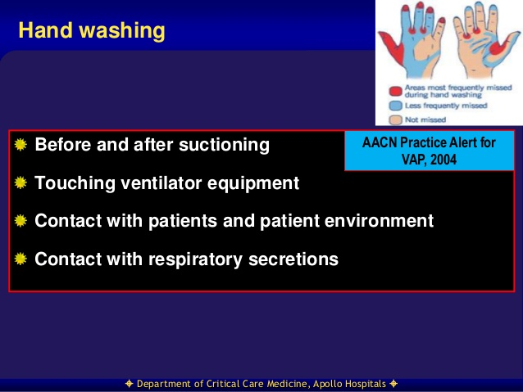
Elevation of the Head of the Bed
Supine head position associated with a 3-fold increased risk of pneumonia.
To prevent aspiration and gastric reflux .
elevate head of the bed to > 30°
Weaning Protocols and Sedation Vacation
Removing endotracheal intubation tube is the best way to prevent VAP.
Protocols that nurses can use to shorten the length of time patients are intubated.
These methods appear to decrease rates of VAP.
Definition of Weaning
The transition process from total ventilatory support
to spontaneous breathing. This period may take many forms ranging from abrupt withdrawal to gradual withdrawal from ventilatory support
Premature withdrawal can result in:
Ventilatory muscle fatigue.
Compromised gas exchange.
Loss of airway protection.
Higher mortality rate.
Decision to wean depends on:
Patient’s recovery from the problems that imposed the need for mechanical ventilation .
Patient’s overall clinical condition and psychological state.
Daily Sedation Vacations
Included in sedation protocol (8 a.m.) each morning sedation is held unless order written that contraindication exists.
Contraindications:
Critical airway.
Unstable respiratory or CV status.
Restart sedatives and analgesics at ½ previous dose.
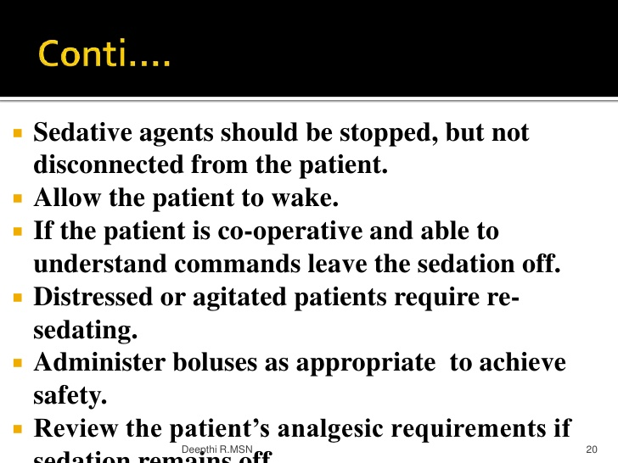
In-line Suction Catheters
1)Open suction method.
(2)Closed suction method..
(3)Continous suctioning of subglottic secretions
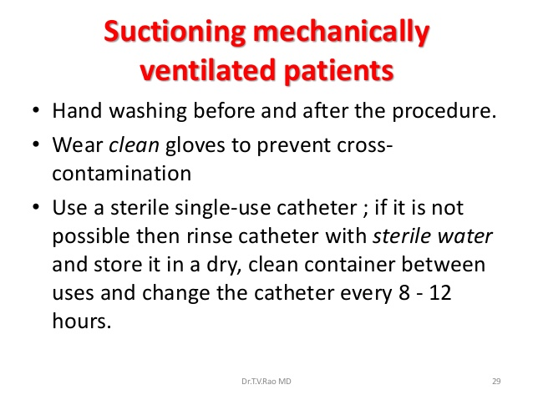
Oral Care to prevent VAP
Used to reduce the density of oral flora that may be aspirated and cause VAP.
Timing:
Every 2-4 hrs (antiseptic mouthwash) with toothette or wrap clean gauze round gloved finger, soak with mouthwash, gently rub gums and tongue, rinse.
2-3 x per day (tooth brushing) .
CHG for oral care recommended by most new guidelines.
Chlorexidine 2% better than lower doses
Concerns about emergence of resistance to CHG
Most important principals:
Mechanical friction essential to decrease organisms
Choose product with low alcohol content to avoid dryness that will leave mucous membranes susceptible to infection.
In neonates normal saline or even breast milk is used.
Reprocessing Ventilator Equipment
Category semi-critical (direct or indirect contact with mucous membranes)
PRE-WASH: Wash/wipe to remove visible soiling
HIGH-LEVEL DISINFECTION:
pasteurization (hot water) at >70oC for 30 minutes.
steam sterilization.
liquid chemical disinfectants for use on medical instruments.
RINSING: (if using chemical disinfectants)
with sterile water.
filtered water (0.2micrometer filter) or tap water
alcohol rinse
:DRYING
Air dry .
Forced air after alcohol rinse (for non-sterile water rinse).
Routine Changing of
Respiratory Equipment:
Previous recommendation: change ventilator circuits routinely on the basis of duration of use should be changed .
Risk of acquiring pneumonia when breathing circuits unchanged for the duration of ventilation was not higher when breathing circuits were changed routinely .
NEW Recommendations: change on based visual and/or known contamination of the circuit.
Result = large savings in device use and personnel time .
Care of Ventilator Accessories
Periodically drain and discard any condensate that collects in the tubing of a mechanical ventilator
Do not to allow condensate to drain toward the patient
Wear gloves for the procedure or handle the fluid and perform hand hygiene after it .
Use sterile (not distilled, non-sterile) water to fill bubbling humidifiers.
Ulcer Prophylaxis
Use of H₂ blockers, PPI, or gastric coating agent(Sucralfate).
DVT Prophylaxis Option:
Lovenox, SCD (sequential compression devices).
Selective decontamination for the digestive tract (SDD)
preventing oropharyngeal and gastric colonization with aerobic GNB and Candida spp, without disrupting the anaerobic flora .
locally administered nonabsorbable antibiotic (eg, polymyxin) and an aminoglycoside or fluoroquinolone + amphotericin B or nystatin.
Either orally or through GT.
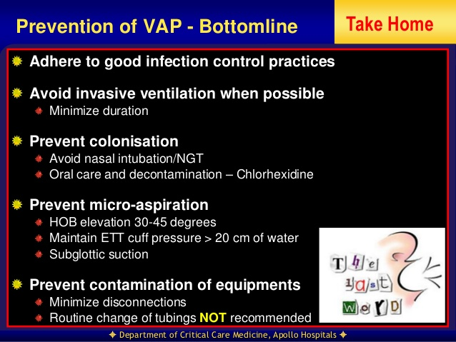

TREATMENT
Inadequate empiric therapy of VAP is associated with adverse outcome. However, prolonged broad spectrum antibiotic treatment is associated with emergence of multiresistant organisms, increased costs and, most importantly, masking non-pulmonary sites of infection. As it is difficult to obtain samples free of oropharyngeal contamination by conventional endotracheal aspiration, either bronchoscopic or nonbronchoscopic lower airway sampling is preferable
An empirical regimen of an advanced macrolide plus a second- or third-generation cephalosporin or a beta-lactam/beta-lactamase inhibitor is recommended
When to start:
Increased mortality if delays in Abx administration. Excess mortality of inappropriate Abx is not reduced on correction of regimens when culture results arrive 24-48hrs later.
How long:
Although the duration of empiric therapy is traditionally 14 to 21 days, in patients with good clinical response with resolution of infection, it can be shortened to 7 days, except when treating P. aeruginosa, Acinetobacter species or other non-fermenters.
How many Abx:
Monotherapy for early, Combination therapy in late onset (>72 hrs)
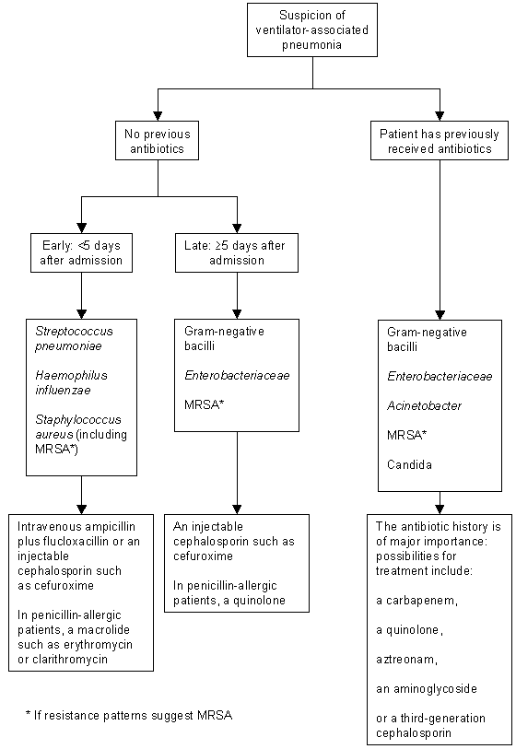
De-escalation Strategy
A new approach known as ‘de-escalation’ strategy has been suggested for effective delivery of appropriate empiric therapy for VAP, without the overuse of antibiotics. De-escalation refers to use of microbiologic and clinical data to change from an initial broad-spectrum, multi-drug empiric therapy regimen to a therapy with fewer antibiotics and agents of narrower spectrum.
